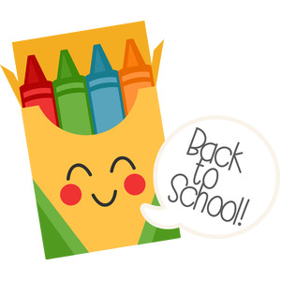Materials That You will Need For Art

1. Sharpened Pencil
2. Eraser
3. Sketchbook
4. Crayons
5. Markers
6. Hand Sanitizer
7. Scissors \*
8. Colored Pencils \*
9. Watercolor Paints \*
10. Tempera Paints\*
11. Brushes\*
12. Oil Pastels\*

\* These are (only needed) for virtual learning. If you cannot get them, it is ok. You can substitute with other materials. Please, Do Not Bring these to school. (Scissors will be taken by Security)

When we do return to school, all of your materials should be in a clear zip lock bag with your name, grade and section on it. (You can use an art box in place of the zip lock) You will need materials 1-6 every art class. (Normally I would provide markers, and crayons to share, but due to Covid 19, we need to limit sharing materials)

Please contact me at [cunninghamm@hasdk12.org](mailto:cunninghamm@hasdk12.org) if you have any questions, concerns, or trouble getting materials.